# **INTRODUCTION**

## About GO-JEK

GO-JEK has officially expanded its market to Southeast Asia including Vietnam with new technology investment in GO-VIET. One of the future promises that GO-VIET will be the provider of ride-hailing, logistics and digital payments services on the battle with Grab.

GO-JEK was founded in 2010 with its predecessor - the company providing motorbike taxi service on the mobile platform, also known as ride-hailing technology. GO-JEK not only offers ride-hailing services but instead dozens of other services can be deployed through this application. GO-JEK offers a wide range of services such as 2-wheel and 4-wheel mobile vehicles, shopping, housekeeping, health care and car repair services. This is what Grab and Uber in Vietnam does not have and may be a good point if GO-JEK start running in this country.

Reported on 2018: The application of GO-JEK company has been downloaded more than 60 million times in Indonesia, according to a press release last month. GO-JEK has over 900,000 registered drivers in the country and facilitates over 100 million transactions a month.

## About GO-VIET

GO-VIET is proud to be a strategic partner of GO-JEK, providing multi-service applications with four-wheel and two-wheel drive transportation solutions, ordering, delivery and many other services. Serving the daily needs of Vietnamese users.

With GO-JEK's advanced world technology platform, GO-VIET aims to improve the quality of life for our users and create value for our partners and communities.

Besides to the riding service, goods delivery, shopping, GO-VIET is the solution to help you handle daily needs easily, conveniently and quickly.

GO-VIET cooperates with thousands of driver partners, restaurant partners and other partners in Viet Nam to bring you a comfortable experience on every service. GO-VIET's products are aimed at facilitating users and solving social problems such as employment, income and business development of small and medium enterprises.

# EXISTING IT SERVICE SCOPING

GO-VIET is an application for ride-hailing, online shipping, food delivery, billing and daily services. At the moment, GO-JEK invests more than US $ 500 million in 4 markets in South East Asia including Vietnam, Singapore, Thailand, Philippines. With that amount of money, GO-VIET in Vietnam is the biggest competitor of Grab in Vietnam, when it owns more than 95% of the market ride-hailing technology.

## Current services

GO-VIET is currently providing a variety of mobile transporting and shipping services including:

* **GO-RIDE**

GO-BIKE is a motorcycle drive technology service of GO-VIET has just launched, application will connect motorbike drivers with customer using GO-VIET application to solve the traveling needs of customer as well as increase additional income for the driver.

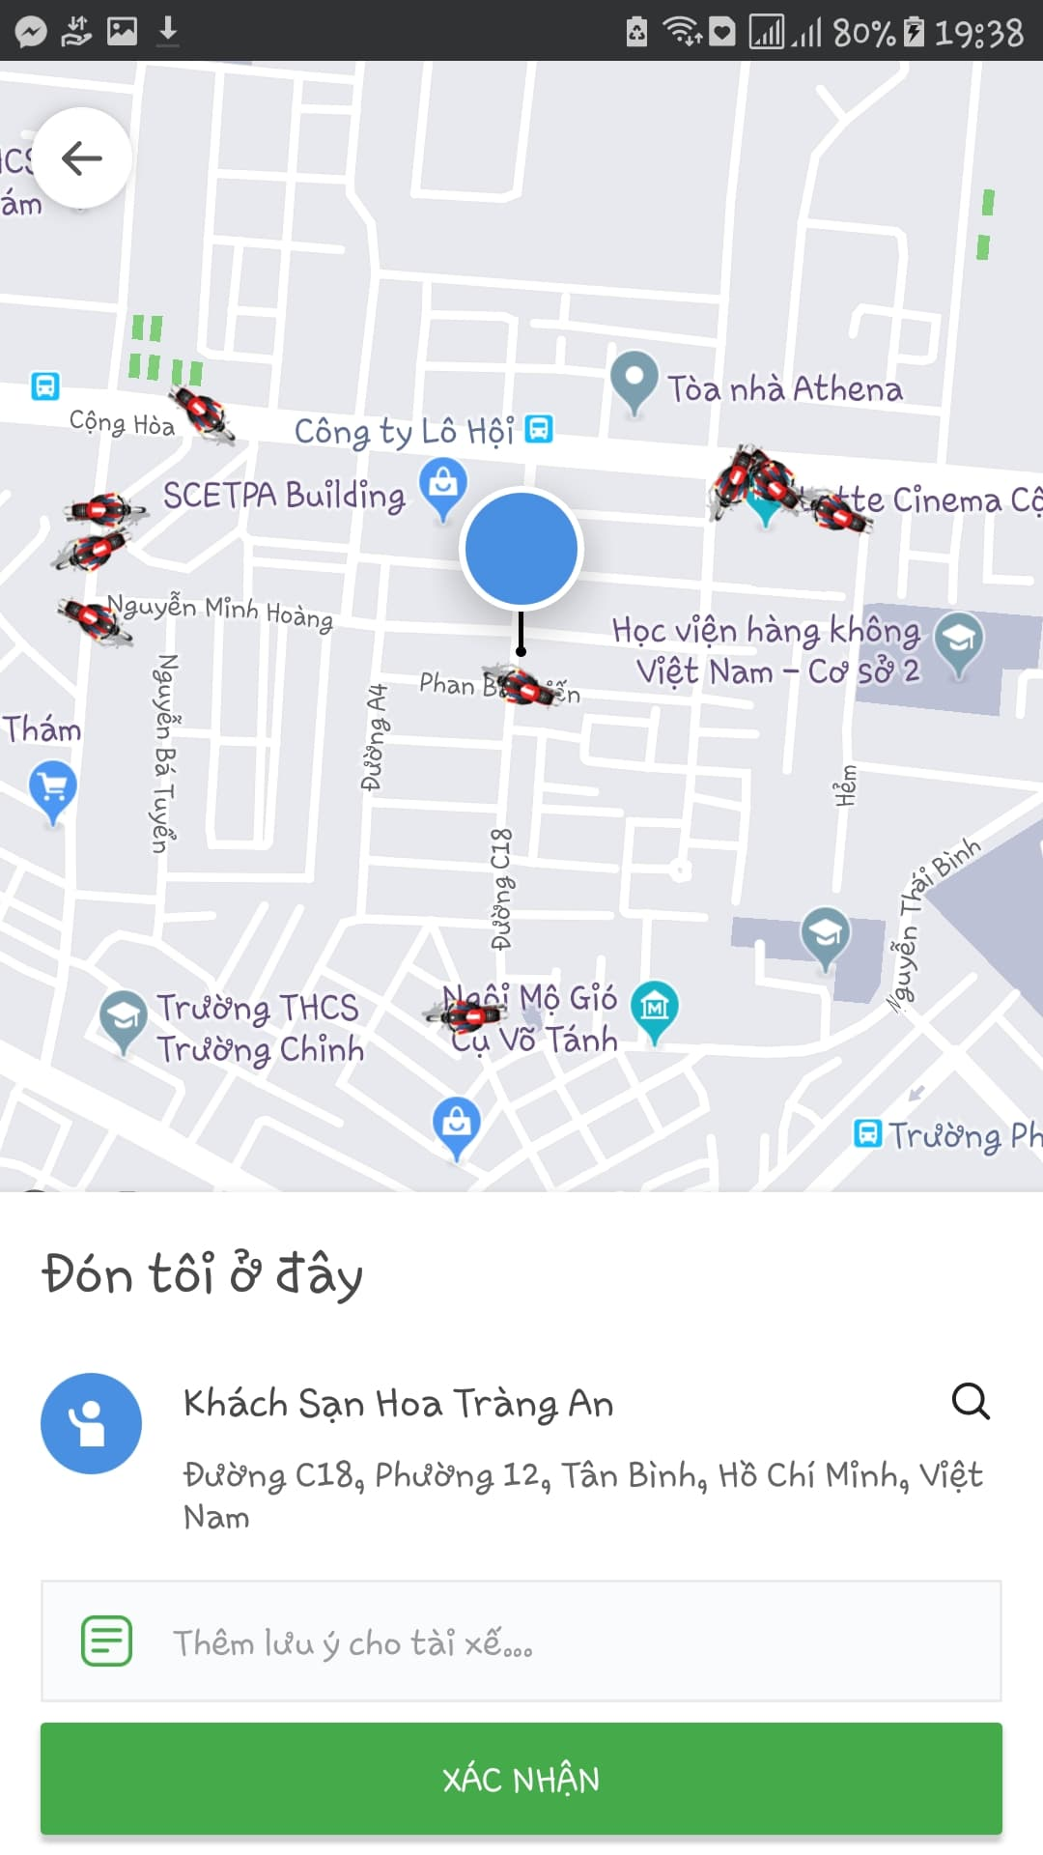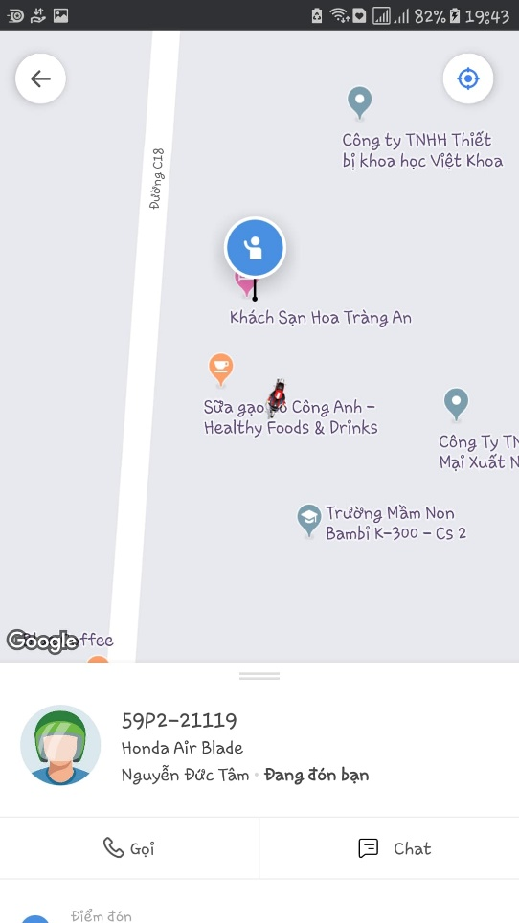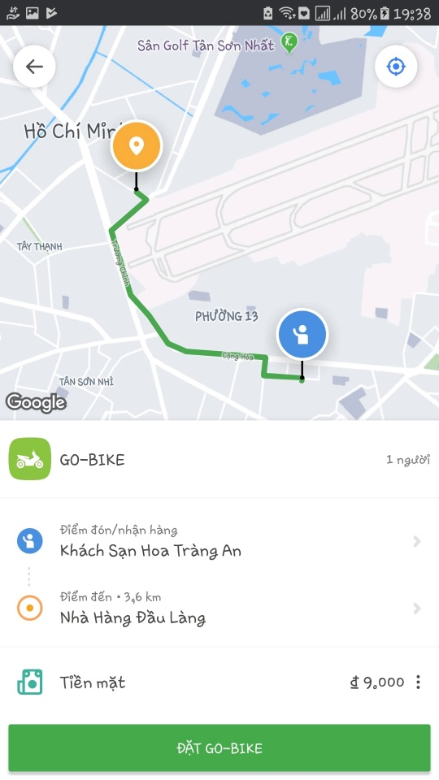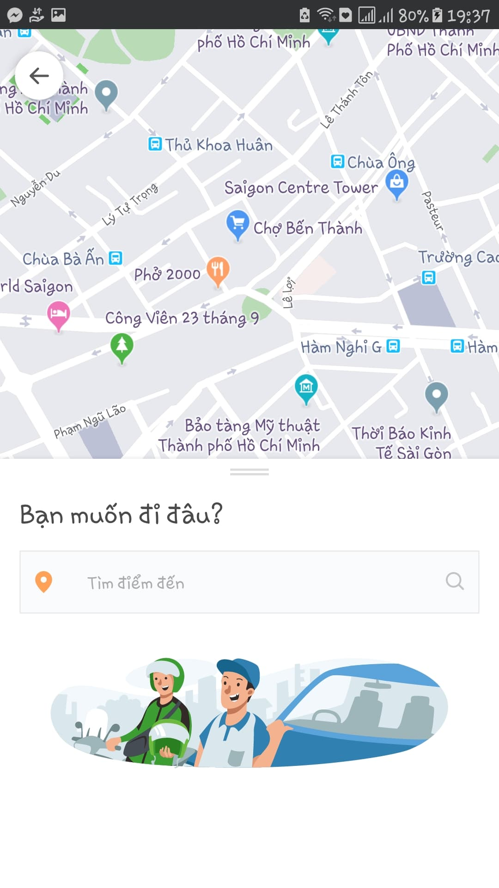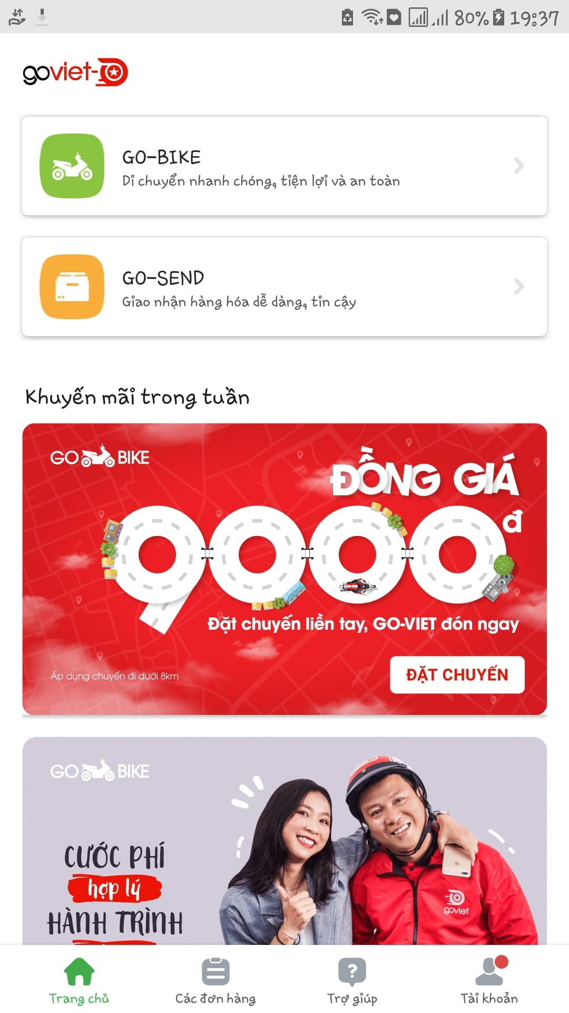

* **GO-SEND**

GO-SEND is a GO-VIET motorbike delivery service for customer who wish to book the delivery. You can easily deliver letters, goods, gifts, products safely, quickly and economically. Commodities will be delivered by GO-BIKE drivers of GO-VIET to increase driver's income as well as cost savings for customer.

When using GO-BIKE and GO-SEND, customers don’t have to worry about the distance, price or time because even it’s far or near, day or night, dry or wet, GO-Driver will happy to delivery their customer’s goods to the location. That’s the strong side of GO-VIET which made this company become the 1st competitor of Grab nowadays.